KGNU Listening Stations

Questions? Contact Jiffer Harriman

[jifferh@gmail.com](mailto:jifferh@gmail.com)

720.839.4916

**Listening Station Setup and function**

Power it with a micro USB cable and plug headphones or other to the 1/8” jack.

Each button of the listening stations cycles through a playlist (or may be a single track). The playlists are collections of .wav files stored in folders on the mini-SD memory card.

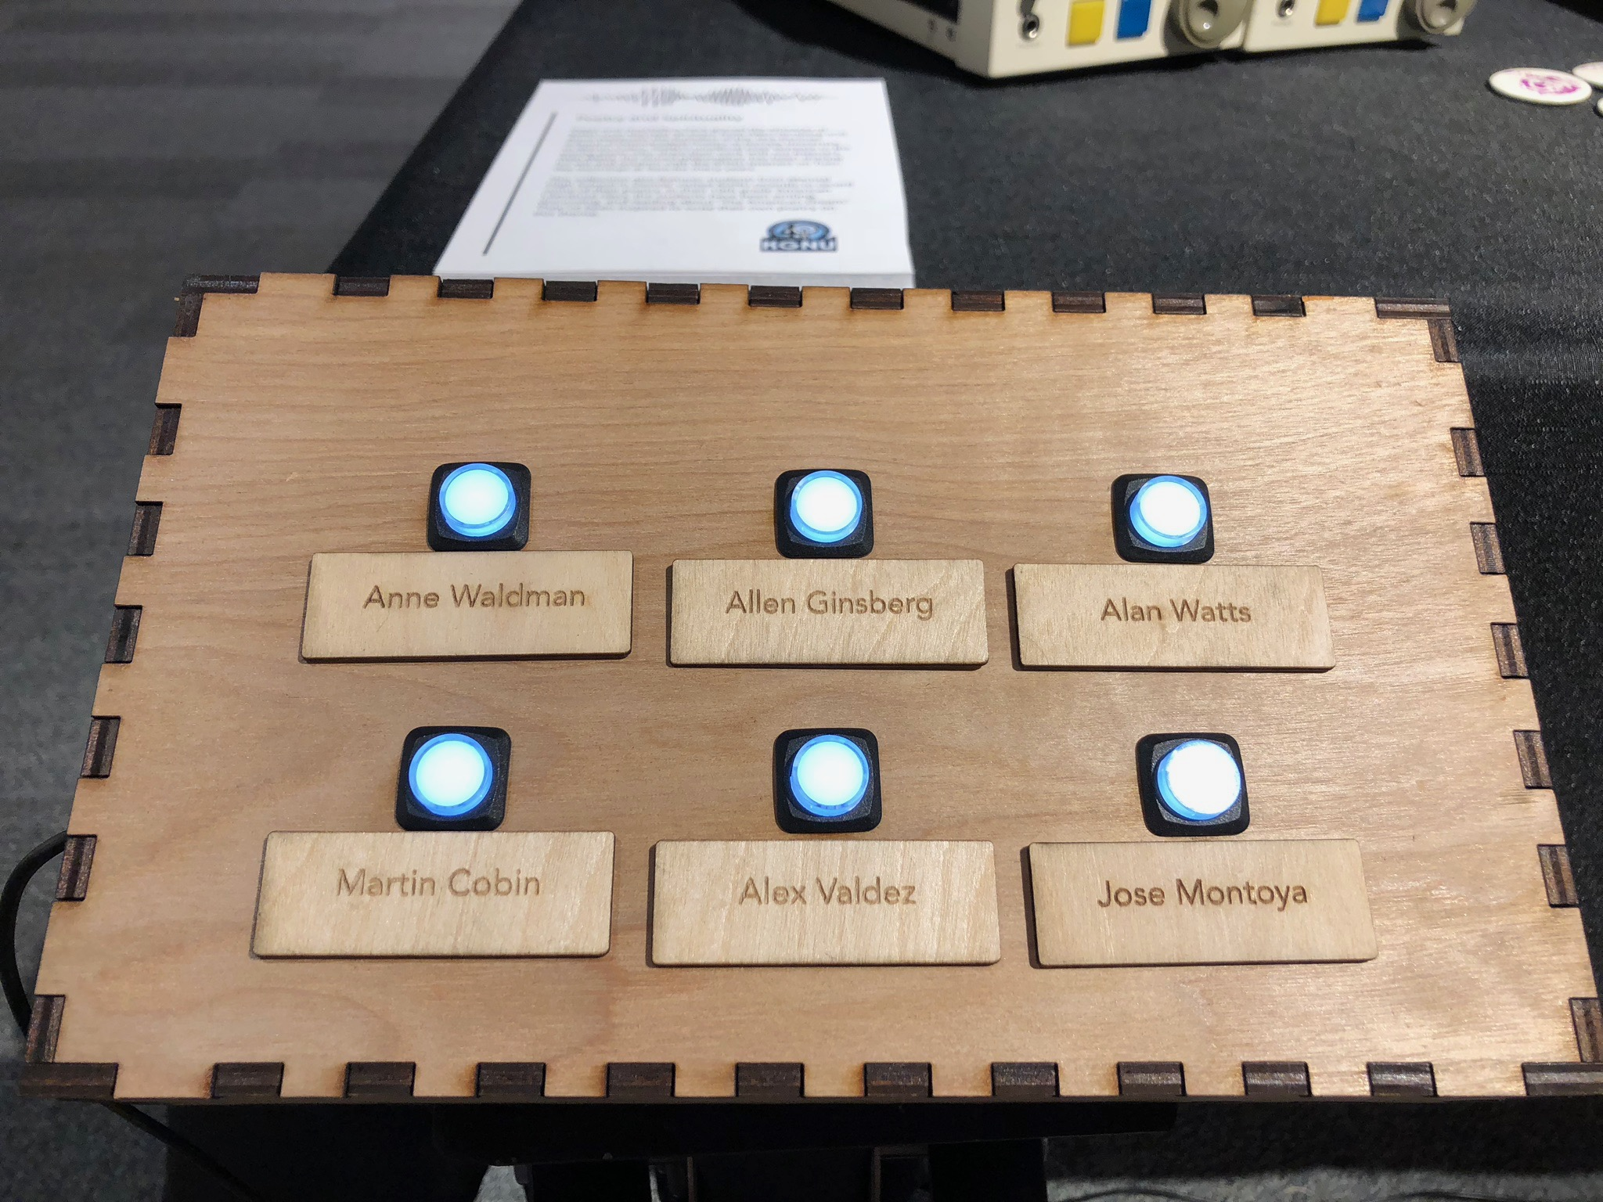

After pressing a button the remaining buttons will go dark with the selected button remains lit. During this time any button presses are ignored. After a couple seconds the lights turn back on and a new track can be selected.

**Changing the audio files**

Remove the mini SD card from the slot via the rectangular hole on the bottom of the Listening Station boxes.

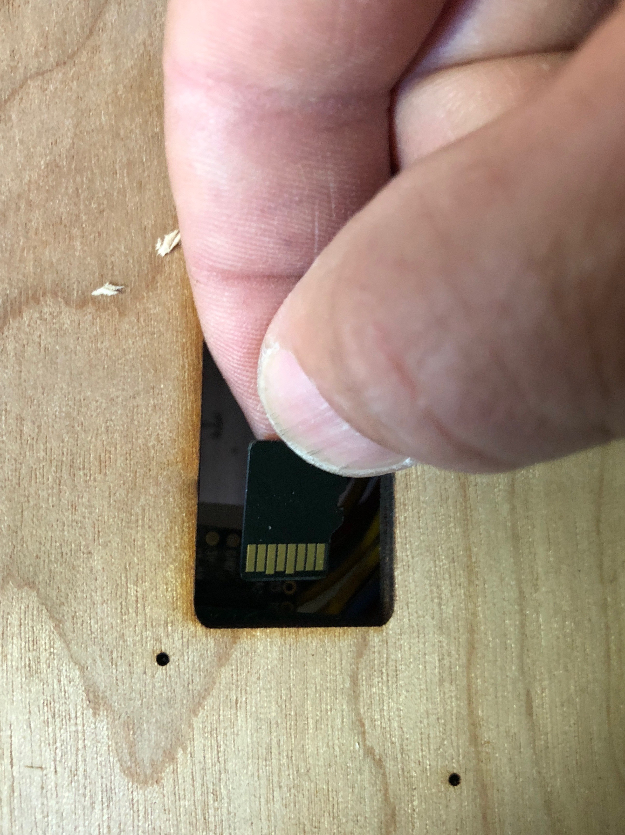

*The contacts of SD card face the bottom of the box.*

Use a mini SD card reader to modify the content of the folders on a computer. After updating the contents of the mini SD card place it back in the slot.

**Folder Format**

Each folder corresponds with a button on the interface. The boxes have between 2 – 6 buttons. The folders are named A-F.

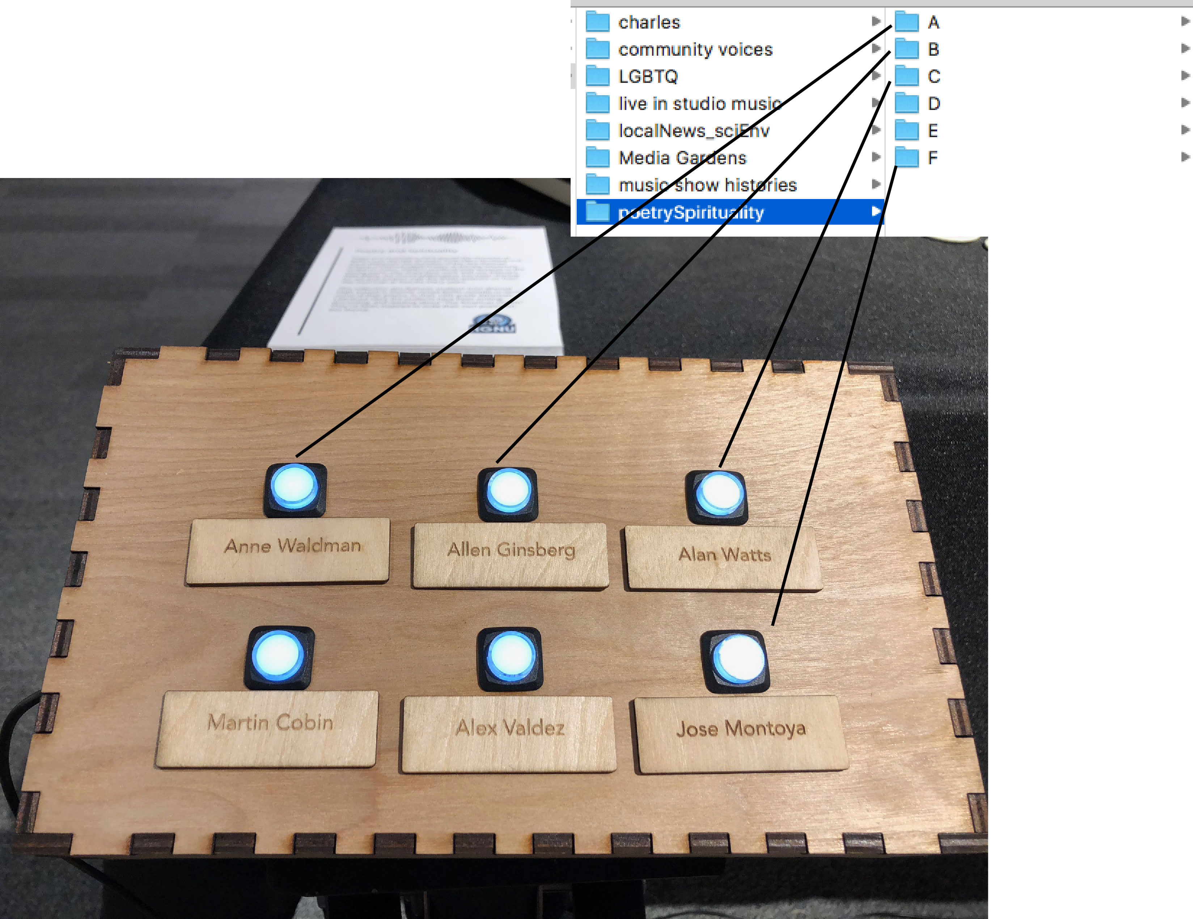

**WAV file format**

Files that do not match this format may not play:

Stereo or mono

16 bit

44.1kHz

**File Names**

Alphanumeric order of the names will determine the playlist order.

The file names must contain 8 or fewer characters for this hardware platform.

**Original Formatted audio files and SD card images**

The files originally put on the listening stations were in the order shown in the following screenshots. The original images were put on an extra mini SD card.

**Live studio**

Folder A:

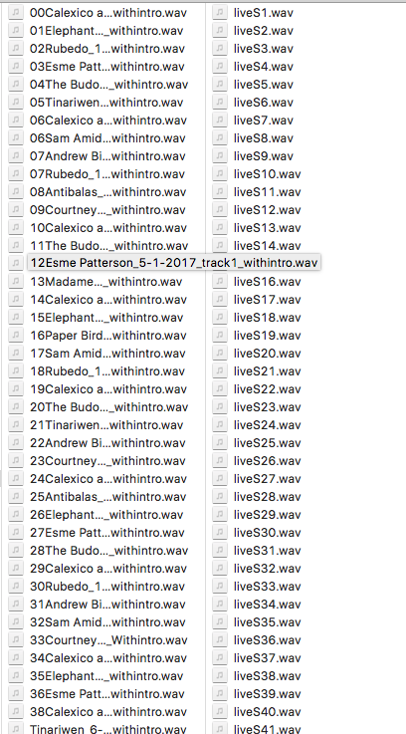

Folder B:

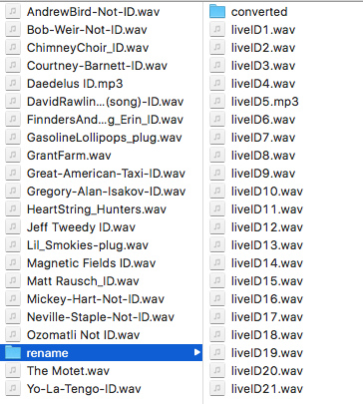

**Music Histories**

Folder A:

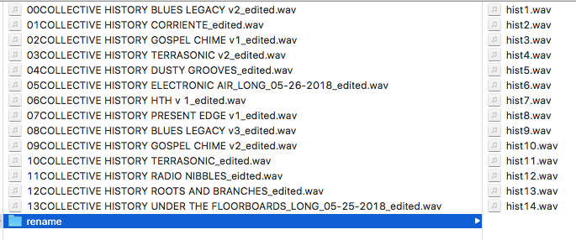

Folder B:

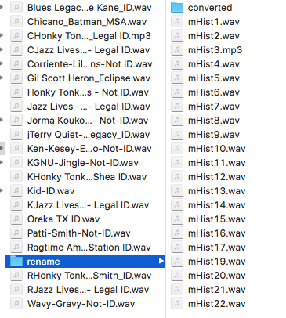

**Charles**

Folder A:

Folder B:

**Local News / Science and Environmental**

Folder A:

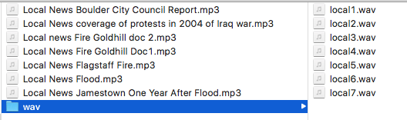

Folder B:

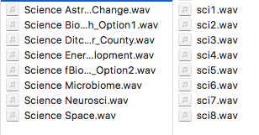

**Community Voices**

Folder A:

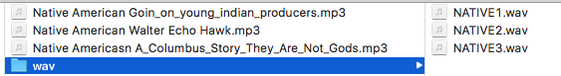

Folder B:

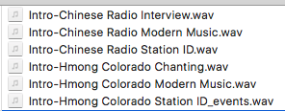

Folder C:

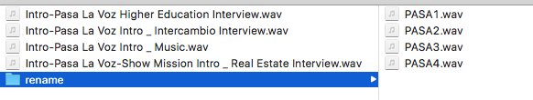

**Poetry and Spirituality**

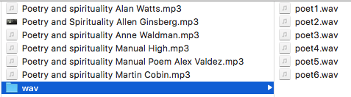

**LGBTQ**

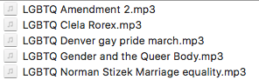

**Media Gardens**

Folder A:

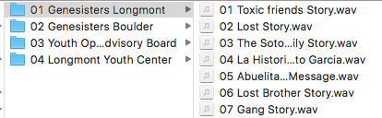

Folder B:

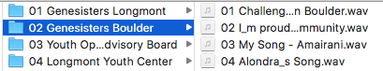

Folder C:

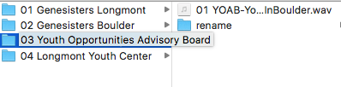

Folder D:

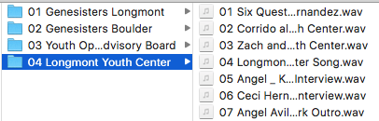

**Source Code**

Download here:

<https://github.com/Jiffer/KGNU-Listening-Station>